Our Ref: _______________ Your Ref: ________________________ Date: __________________

Baptist Church

Baale Yaku Site Area, P. O. Box 644,

Ogbomoso, Oyo State. Tel. 07052425407

Email: [newsprinbaptistchurch@gmail.com](mailto:newsprinbaptistchurch@gmail.com)

Website: newspringbc.comze.com

NEW SPRING

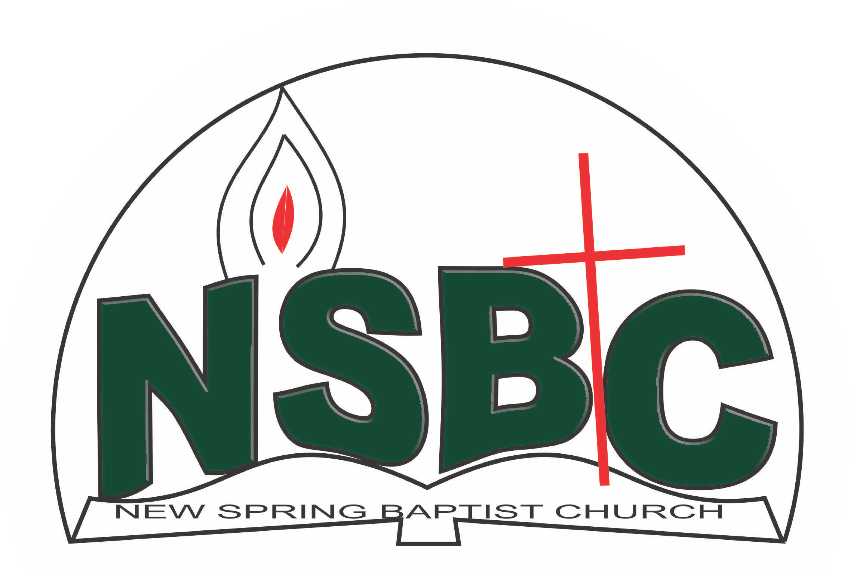

2 January 2022

Dear Mr. Moses Fasola ,

Nomination to Serve as a Worker in the Church in 2022.

Calvary greetings in the precious name of our Lord and Saviour Jesus Christ. It is our pleasure to inform you that at the Church-in-Conference held on December 19, 2021; the Church ratified your nomination to serve in the following areas between January 1 and December 31, 2022:

1. Mission & Evangelism Coordinator/External Affairs, Youth Fellowship under the leadership of Mr. Victor Ayansola

Please refer to the table below for the key functions of each of these roles. Details can be found in the Church constitution. You are strongly encouraged to become familiar with the tasks as stated in the document. There will be an orientation of the Church workers on January 22, 2022 at 8:30 a.m. on the church premises. Please ensure you participate in this training.

“Now it is required that those who have been given a trust must prove faithful. I Corinthians 4:2”. May God find you faithful in the task He has assigned to you.

| Domain | Key function of Office, Department or Committee |
| --- | --- |
| Mission & Evangelism Coordinator, Youth Fellowship | Responsible for the mobilization of Youth members for soul winning activities. |
| Ecumenical Affairs Youth Fellowship | To represent the Youth Fellowship and participate in the activities of umbrella organisations that the Church belongs to such as Christian Council of Nigeria, Bible Society. |
| Media & sound Committee | To ensure the public address system is working properly during worship services and other Church programmes where a public address system is required & The unit shall provide technical support in the use of electronic equipment to enhance worship experience |

Thank you for accepting to serve in this Church.

Yours in His service

Olusayo Okediji Blessed Agboola

Church Secretary Chairman, Nominating Committee